Exercise: Networks, Internet and Protocols

Problems for exercises and homework for the "Software Technologies" course @ Software University

Trace the route/connectivity to a certain IP address
1.1. Use the "tracert" command to test route to an external website of your choosing /Example: wikipedia.com/
1.2. Use the “ping” command to test connectivity to an external website of your choosing
2. Add a screenshot of the result here:

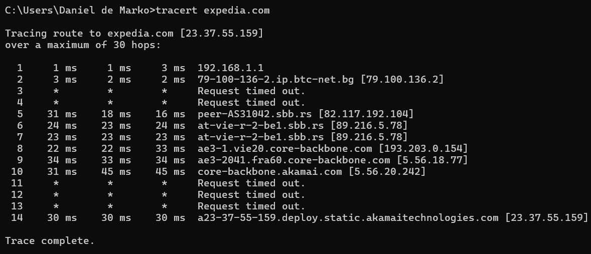

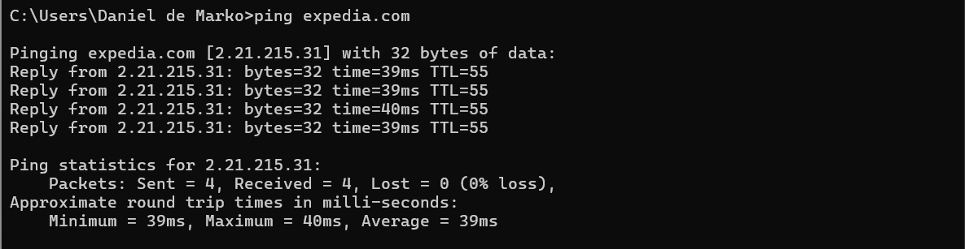

Find the IP address behind a domain name
1. Using an online DNS lookup tool, like or MX Toolbox find the IP address of a domain. /Example: medium.com/
2. Add a screenshot of the result here:

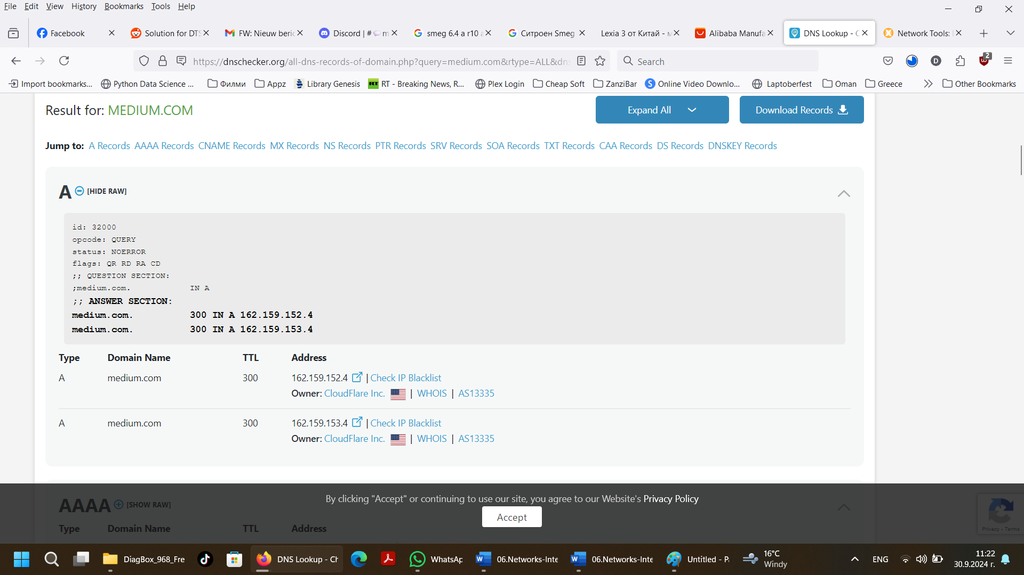

Execute HTTP GET
1. Using https://restcountries.com/ and DevTools on your browser. Execute a GET request for a country of your choosing. /Example: https://restcountries.com/v3.1/name/deutschland/
2. Add a screenshot of the result with DevTools open here:
